URS Kaggle Tip dataset analysis and ANN model development
Source: https://www.kaggle.com/datasets/varishabatool/tip-prediction-dataset
Varibale overview:
- sex : gender (male or female)
- smoker : (Yes, No)
- Day : Thursday, Friday, Saturday, and Sunday
- Mealtime : (dinner or lunch)
- size : The number of guests at the dinner party
Objcetive: Maximize tip revenue through optimal resource allocation, strategic scheduling based on comprehensive data analysis of 244 datasets and build of ANN model.
- Dataset overview and summary:
Variable | Type | Description
total_bill | Numerical | Restaurant bill amount in dollars ($3.07 - $50.81)
tip | Numerical | Tip amount in dollars ($1.00 - $10.00) - TARGET VARIABLE
sex | Categorical | Gender of bill payer (Female, Male)
smoker | Categorical | Whether party included smokers (No, Yes)
day | Categorical | Day of week (Thur, Fri, Sat, Sun)
time | Categorical | Time of day (Lunch, Dinner)
size | Numerical | Number of people in party (1-6)
Table 1 Dataset overview
• Total Transactions: 244
• Average Tip: $3.00
• Average Bill: $19.79
• Average Tip Percentage: 16.08%
• Total Tip Revenue: $731.58
• No Missing Values: Dataset is clean and ready for analysis

- Exploratory data analysis:
  - Relationship between total bill and tip
By plotting total bills and tips on a scatter plot, there is a positive correlation with the R^2 = 0.4566 and correlation = 0.676, showing a mediate positive linear relationship between these two variables. The relationship is clear: guests tend to leave higher tips when the total cost of their meal is higher. The data points cluster well along an upward-sloping line with the regression equation Tip = 0.105 × Total Bill + 0.920. The data points cluster well along an upward sloping line, supporting the use of a simple linear model to predict tips based on the bill.
On the right plot, color-coded by party size, it is used to investigate the hypothesis: "with increasing party size, tips will increase." This hypothesis is generally supported by the graph, showing that larger groups (represented by yellow/green points) tend to cluster toward higher bill amounts and correspondingly higher tips.
However, parties of size 5 or 6 show higher variability than smaller groups, manifesting as a wider vertical spread of data points. This higher variability is primarily due to the small sample size for parties of 5-6 people: only 9 transactions representing just 3.7% of the dataset.
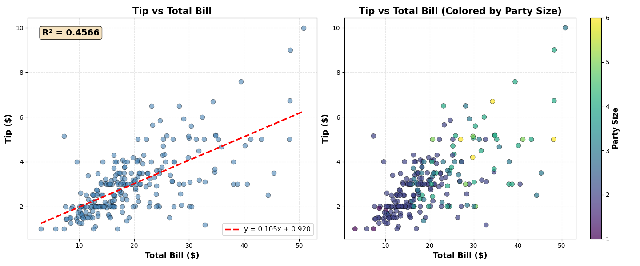
Figure 1 Scatter plot between total bill and tip as well as colored party size data points
To dig deeper into the relationship between tips and party size, I construct a box plot to track the mean tip trend across different party sizes. As shown in Figure 2 (left side), there is a clear increasing trend in mean tip amount. The mean tip grows steadily from $1.44 for solo diners to $5.22 for parties of six. Notably, in the table 2, the highest average tip percentage increase occurs when group size increase from 1 to 2.

The overall trend indicates that each additional guest contributes approximately $0.69 to the tip amount (Table 1).
Size | Average Tip ($) | Average Tip percentage difference
1 | 1.44 | -
2 | 2.58 | 79.17%
3 | 3.39 | 31.40%
4 | 4.14 | 22.12%
5 | 4.03 | -2.66%
6 | 5.22 | 29.53%
Trend | + 0.69 per additional guest
Table 2 Tip amount by party size numerical analysis

While the absolute tip amount analysis reveals that larger parties pay more in dollars, this measure alone does not capture the relative generosity of different party sizes.
- Smaller groups naturally have smaller total bills, making it intuitive that they leave smaller absolute tips. Tip percentage normalizes tips across different bill amounts, allowing fair comparison between a $7 meal and a $35 meal
- While larger parties contribute more total dollars, they may be less generous proportionally. For instance, a party of four paying a $28.61 bill and leaving a $4.14 tip (14.59%) is tipping less generously than a solo diner paying $7.24 and leaving $1.44 (21.73%).
Therefore, to comprehensively understand tipping behavior, I analyze tip percentage by party size, calculated as (tip / total bill) × 100.
Figure 2 (right side) displays box plots of tip percentage distributions across party sizes, with mean values overlaid and reference lines at 15% (standard tipping) and 20% (generous tipping). The analysis reveals a significant negative correlation (r = -0.143) between party size and tip percentage, demonstrating that as party size increases, the percentage of the bill left as a tip decreases.
Size | Avg Tip % | Std Dev | Min % | Max % | Count | Avg Bill ($)
1 | 21.73% | 8.03 | 13.79 | 32.57 | 4 | 7.24
2 | 16.57% | 6.68 | 3.56 | 71.03 | 156 | 16.45
3 | 15.22% | 4.55 | 5.64 | 23.07 | 38 | 23.28
4 | 14.59% | 4.24 | 7.75 | 28.05 | 37 | 28.61
5 | 14.15% | 6.77 | 6.57 | 24.17 | 5 | 30.07
6 | 15.62% | 4.22 | 10.38 | 19.53 | 4 | 34.83
Trend | -0.92 percentage points per additional guest
Table 3 Tip Percentage by Party Size
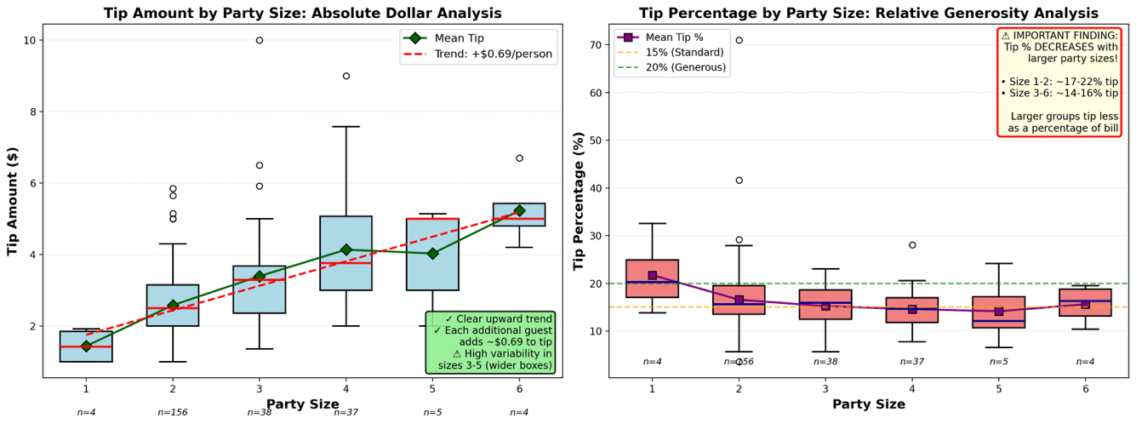
Figure 2 Tip amount by party size (left) and tip percentage by party size (right)

  - Tip distribution by sex:
Violin plots reveal the distribution of tips between male and female customers. Both groups show similar tipping patterns with comparable median values, except for male shows a longer tail.
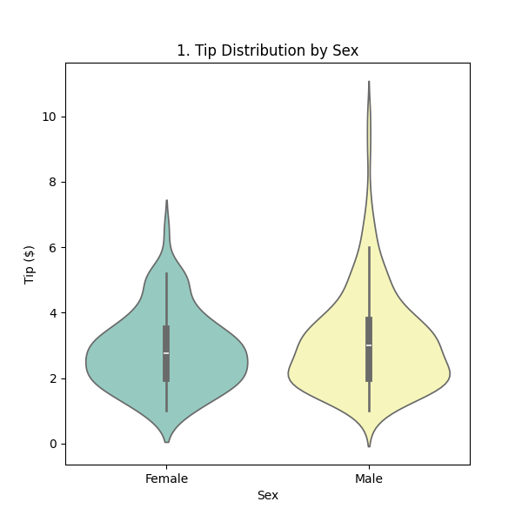
Figure 3 Tip distribution by sex
  - Tip distribution by smoker status
Comparison of tipping behavior between smoking and non-smoking parties shows minimal differences in tip distributions
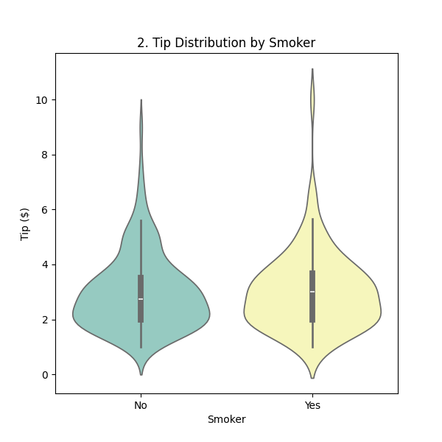
Figure 4 Tip distribution by smoker
  - Tip distribution by day of the week
Saturday demonstrates the highest range of tip and Sunday generate the highest tip media.
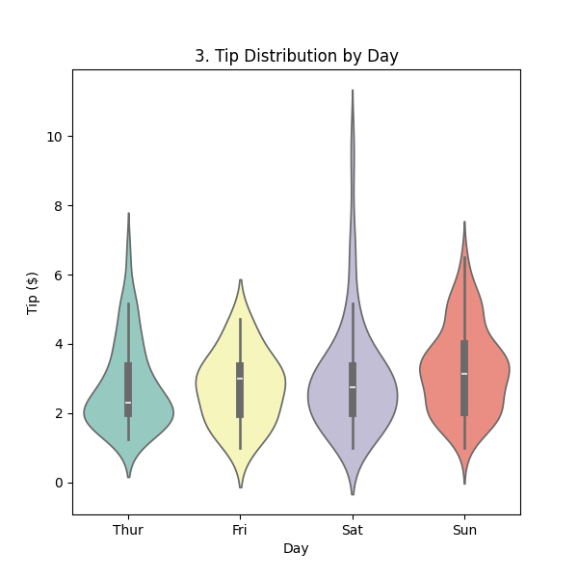
Figure 5 Tip distribution by day
  - Tip distribution by time
Dinner shows a higher tip amounts and greater variation compared to lunch service.
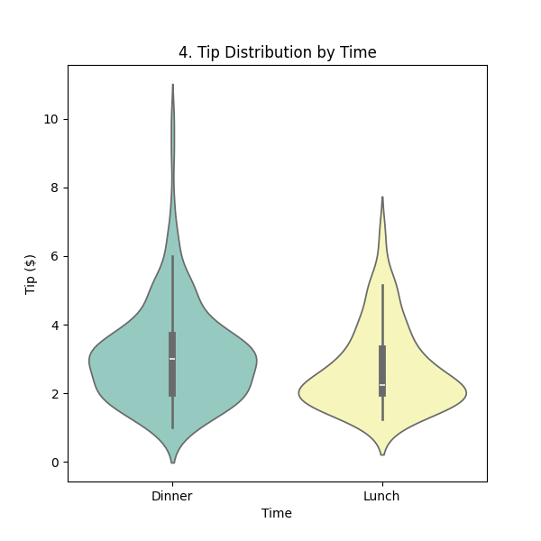
Figure 6 Tip distribution by time
  - Tip distributio by party size
As we analyzed byfore, larger party sizes correlate with higher absolute tip amounts, though smaller parties tend to tip higher percentages.
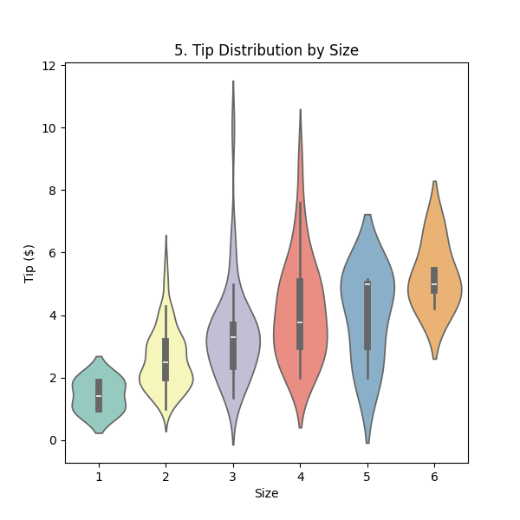
Figure 7 Tip distribution by party size
Therefore, to summarize tip maximization by using above data,
- The best day: Sunday (avg tip: $ 3.26) and Saturday (avg tip $2.99)
- Best time: dinner service (avg tip $3.10, 37% higher than lunch)
Saturday & Sunday dinner shifts generate highest revenue

  - Correlation between variable by using heatmap
Total bill amount is the single most powerful predictor of tip amount. The strong positive correlation indicates that as customers spend more on meals, they consistently leave higher tips. This relationship is foundational and must be included in any predictive model.
Notably, based on the heatmap result, there is a extremely strong correlation between day and time indicates severe multicollinearity. This occurs because lunch transactions cluster on weekdays (Thurs), while dinner transactions concentrate on weekends (Sat/Sun).
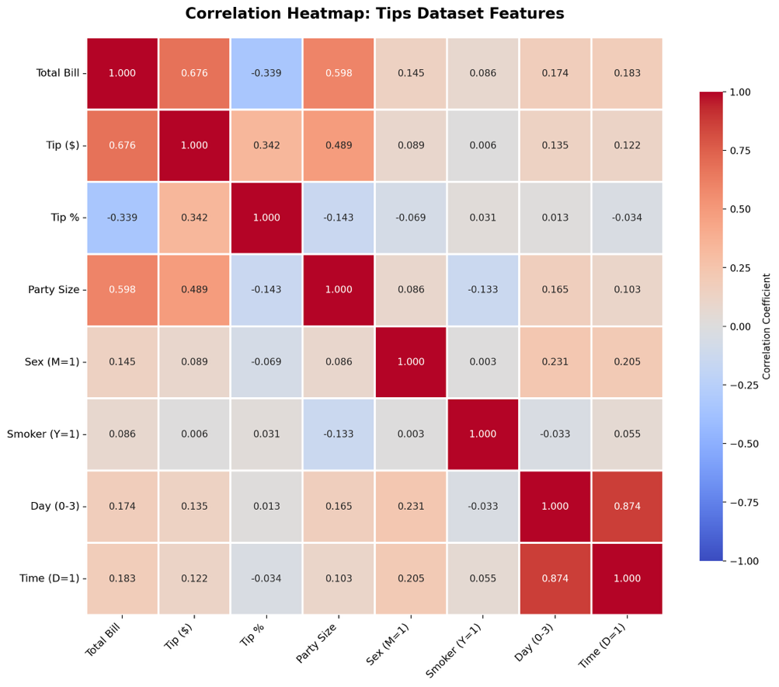
Figure 8 Correlation heatmap: tip dataset features

Rank | Feature | Correlation with Tip ($) | Strength | Key Insight
1 | Total Bill | +0.676 | STRONG | Most important predictor; explains 45.7% of variance
2 | Party Size | +0.489 | MODERATE | Second most predictive; adds significant value
3 | Tip % | +0.342 | WEAK | Derived metric; should NOT be used as input
4 | Day (0-3) | +0.135 | VERY WEAK | Minimal direct correlation
5 | Time (D=1) | +0.122 | VERY WEAK | Lunch/Dinner has weak effect on tip amount
6 | Sex (M=1) | +0.089 | NEGLIGIBLE | Males tip slightly more; very weak effect
7 | Smoker (Y=1) | +0.006 | NEGLIGIBLE | No meaningful relationship
Table 4 Feature Importance Ranking for Tip Prediction

- Building the ANN model for tip prediction
For this analysis, I used an Artificial Neural Network (ANN) with a relatively simple architecture:
- Hidden layer 1: 32 neurons
- Hidden layer 2: 16 neurons
both using ReLU activation.
This configuration balances model expressiveness with overfitting risk, given the small dataset.

Both losses and MAEs drop sharply during the first half of training and then gradually flatten. Notably, the validation curves run very close to the training ones for most epochs, suggesting good generalization at the start.
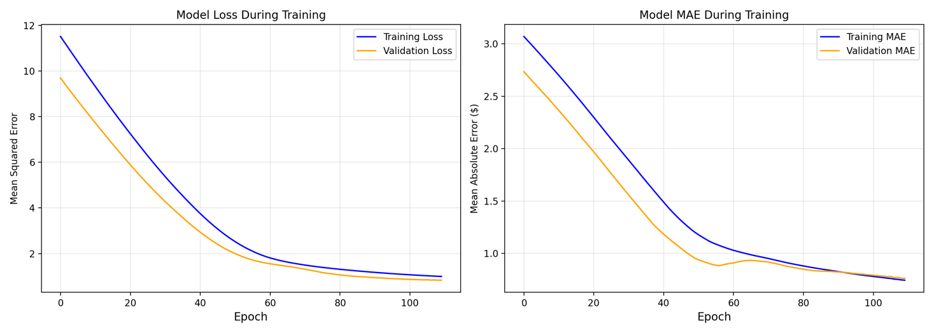
Figure 9 Model loss and MAE during training
In the left panel, the ANN's predictions cluster tightly in the $2–4 range and often fail to capture both the lowest and highest tips, as many points deviate from the dashed perfect-prediction line. Linear regression (right) shows a better spread across the entire range, with points aligning closer to the diagonal. This demonstrates that, even with more flexibility, the ANN is not able to generalize as well.
Model | Test R² | Test MAE ($) | Test RMSE ($)
ANN | 0.18 | 0.83 | 1.01
Linear Regression | 0.46 | 0.75 | 1.02
Table 5 ANN and Linear regression model comparison
ANN's lower R² and higher MAE indicate it is capturing less of the variance than the linear model, a sign it cannot reliably model this problem with the current data size and feature set.
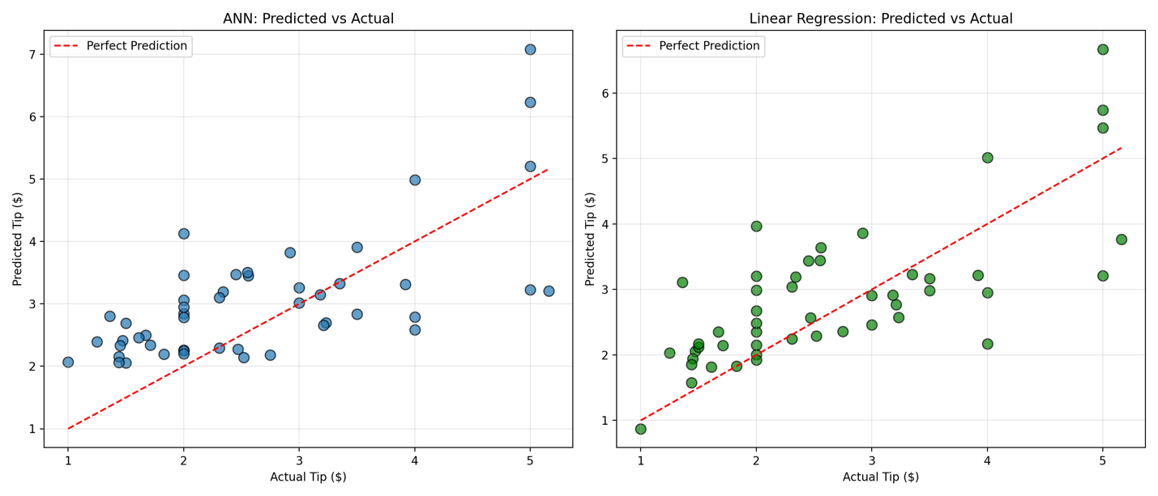
Figure 10 ANN and linear regression: predicted vs Actual comparison

The overfitting indicator plots the difference between validation and training loss for every epoch. Early on, the gap is large and negative (indicating validation loss is much lower than training loss), but it steadily rises toward zero as both losses shrink. The gap peaks, then remains slightly below zero in later epochs.
Based on figure 11, the model avoids severe overfitting (which would show as a pronounced positive gap), but the continual rise toward zero suggests that as training error drops, the model’s benefit on unseen data stops improving. This plateau means further training would do little to boost true generalization, and may instead capture noise.
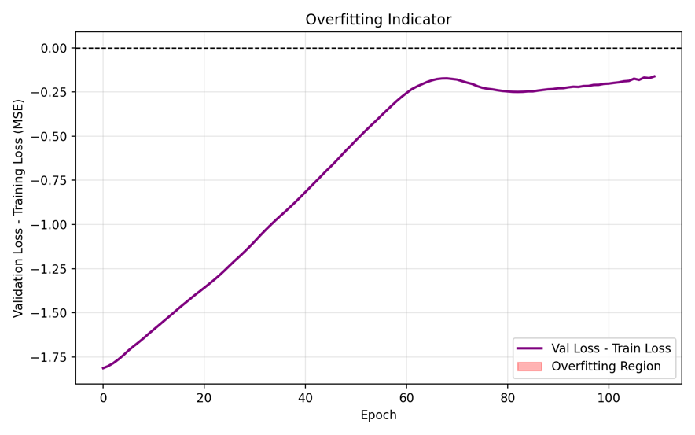
Figure 11 Overfitting indicator

